DDoS-24 Attack Analysis using ML
Date of Submission  Apr 09, 2025 | Instructor  Dr Rizwan Ur Rahman

Abstract

The distributed denial of service attack poses a significant threat to network security. Despite the availability of various methods for detecting DDoS attacks, the challenge remains in creating real-time detectors with minimal computational overhead. Additionally, the effectiveness of new detection methods depends heavily on well-constructed datasets.
Introduction

The DDoS attack poses a significant threat to network security, aiming to overwhelm target networks with malicious traffic. Detecting and mitigating DDoS attacks pose considerable challenges due to their sophisticated and dynamic nature. Traditional detection methods often struggle to accurately identify and stop DDoS attacks in real time, primarily because of their inability to distinguish between legitimate and malicious traffic among the flood of incoming packets. Moreover, as cyber attackers continually evolve tactics, traditional detection mechanisms become increasingly ineffective in identifying newly emerging DDoS attack variants . Consequently, there is a growing recognition of the need to leverage artificial intelligence (AI) techniques to enhance DDoS detection capabilities . AI-based methods, including machine learning (ML) algorithms, rely heavily on data to learn and discern various network behaviors associated with different network activities. However, the effectiveness of these detection methods hinges on the availability of high-quality and comprehensive datasets for training and evaluation purposes. Therefore, at the heart of advancing DDoS detection methods capabilities lies the availability of reliable and comprehensive evaluation datasets.
Rigorous analysis is imperative to extract meaningful insights and validate dataset quality, requiring advanced anomaly detection and classification algorithms. Without clear planning and execution, the resulting dataset may lack fidelity and fail to adequately represent real world scenarios, undermining the effectiveness of DDoS detection algorithms. Therefore, ensuring the integrity and comprehensiveness of the dataset creation process is critical for advancing DDoS detection capabilities and enhancing network security. This research addresses the critical domain of DDoS dataset generation and evaluation, emphasizing the pivotal role of well-constructed datasets in enhancing the efficacy of DDoS detection and characterization algorithms and systems.
Drawing upon this foundational understanding, the pioneering contribution in this work is the introduction of a new cloud-based DDoS dataset named BCCC-cPacket-Cloud DDoS-2024 .The proposed model demonstrates strong performance through extensive testing against di verse DDoS attack scenarios highlighting its potential to strengthen network security defenses.
Dataset Description

The distributed denial of service attack poses a significant threat to network security. The effectiveness of new detection methods depends heavily on well-constructed datasets. After in-depth analysis of 16 publicly available datasets and identifying their shortcomings across various dimensions, the 'BCCC-cPacket-Cloud-DDoS-2024' is meticulously created, addressing challenges identified in previous datasets through a cloud infrastructure. The dataset contains over eight benign user activities and 17 DDoS attack scenarios. The dataset is fully labeled (with a total of 26 labels) with over 300 features extracted from the network and transport layers of the traffic flows using NTLFlowLyzer: https://github.com/ahlashkari/NTLFlowLyzer
The dataset's extensive size and comprehensive features make it a valuable resource for researchers and practitioners to develop and validate more robust and accurate DDoS detection and mitigation strategies. Furthermore, researchers can leverage the 'BCCC-cPacket-Cloud-DDoS-2024' dataset to train learning-based models to predict benign user behavior, detect attacks, identify patterns, classify network data, etc.
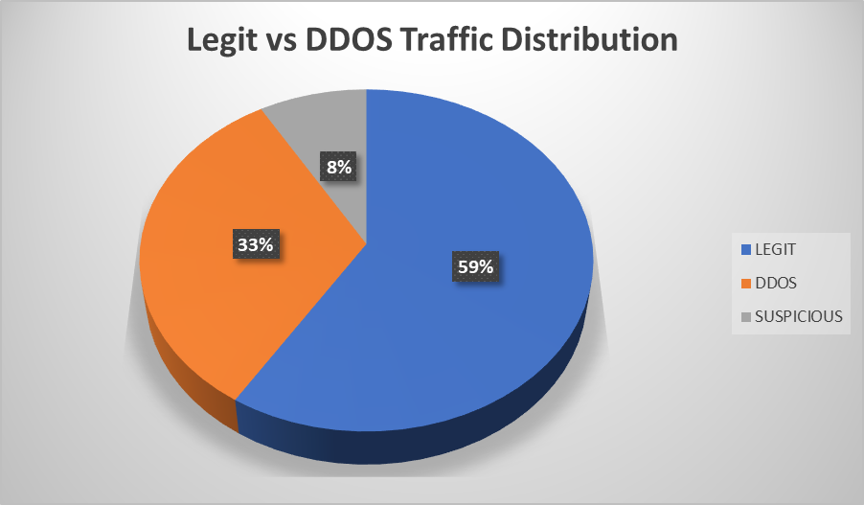
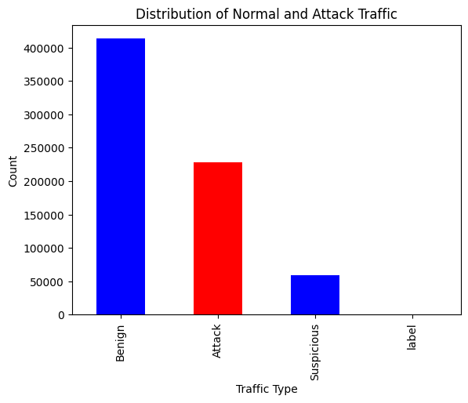
Features Description of Dataset

DDoS attack detection relies heavily on traffic behavior analysis through a variety of features extracted from network flows. These features are broadly categorized into packet-based, flow-based, time-based, and flag-based attributes.
1. Flow-based Features
Flow features such as Flow Duration, Total Fwd Packets, and Total Backward Packets reflect how much data is exchanged and for how long. DDoS attacks often create short-lived or extremely large flows with excessive packets in a short time. Hence, abnormal spikes in total forward/backward packets or sudden surges in flow durations can indicate a potential DDoS.
2. Packet Length Features
Attributes like Fwd Packet Length Mean, Bwd Packet Length Std, or Packet Length Variance describe the size and variation of packets in each flow. Normal traffic tends to have moderate and consistent packet sizes, while attacks may flood the network with unusually small or large packets, either to exhaust resources or evade detection.
3. Traffic Rate Features
Features such as Flow Bytes, Flow Packets, Fwd Packets, and Bwd Packets represent traffic throughput. DDoS attacks are characterized by extremely high packet or byte rates as attackers try to overwhelm the network or application, making these metrics particularly sensitive indicators.
4. Time-based Features
Inter-Arrival Time (IAT) features — like Flow IAT Mean, Fwd IAT Total, and Bwd IAT Std — describe timing gaps between consecutive packets. In normal traffic, these intervals vary based on user behavior and system response. However, in DDoS, packet intervals tend to be uniform and rapid, creating suspiciously low IAT values or highly consistent time patterns.
5. Header and Flag Features
Flags such as SYN Flag Count, ACK Flag Count, and FIN Flag Count indicate control information in TCP packets. DDoS tools may repeatedly send packets with specific flags (e.g., SYN floods), making these counts deviate from normal behavior. Similarly, abnormal counts in Fwd Header Length, URG Flag Count, or PSH Flag Count can also signal crafted or malicious packets used in attacks.

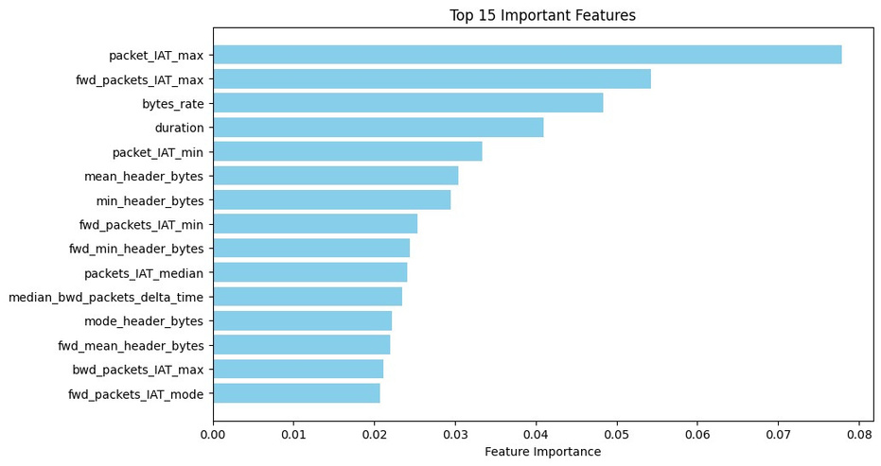
The top 15 features from the BCCC-cPacket-Cloud-DDoS-2024 dataset focus on packet timing, data rate, and header characteristics, which are crucial for detecting DDoS attacks. Inter-arrival time features like packet_IAT_max, fwd_packets_IAT_max, and packet_IAT_min reveal abnormal traffic pacing, while bytes_rate and duration capture flow speed and session length. Header-related features (mean_header_bytes, min_header_bytes) reflect packet structure, and directional metrics (like forward and backward IATs) help analyze traffic patterns. These features together enable effective identification of suspicious or attack-like network behavior.
Models:

- Random Forest
- XGBoost
- Naive Bayes
- LightGBM
- Multilayer Perceptron
- ResNet Style MLP
- Long Short-Term Memory
Random Forest:
Random Forest is an ensemble machine learning algorithm that builds multiple decision trees during training and combines their outputs to improve performance and accuracy. It works by:
- Randomly sampling data points and features .
- Training multiple decision trees on these samples.
- Capable of managing both numerical and categorical data.
Why Use Random Forest for DDoS Attack Detection ?
Random Forest is an ensemble learning algorithm that builds multiple decision trees and merges their results to improve classification accuracy and reduce overfitting. It is particularly effective for DDoS detection due to its ability to handle large, imbalanced datasets and capture complex interactions between features. Compared to individual decision trees or simpler models like Naive Bayes, Random Forest offers greater robustness and higher accuracy. It is less sensitive to noisy data and does not require feature scaling. In DDoS detection, it excels at identifying subtle patterns in traffic behavior that distinguish malicious packets from normal traffic. Its interpretability and feature importance metrics also help in understanding which attributes contribute most to the attack detection, making it a strong baseline model for intrusion detection systems.
Classification Report:
Accuracy: 0.9609
Labels | Precision | Recall | F1-Score | Support
1 | 0.98 | 0.98 | 0.98 | 123876
3 | 0.96 | 0.95 | 0.96 | 68535
4 | 0.85 | 0.89 | 0.87 | 17725
Macro Avg | 0.93 | 0.94 | 0.93 | 210136
Weighted Avg | 0.94 | 0.96 | 0.96 | 210136
Note: Support refers to the number of actual occurrences of each class in the dataset (i.e., the number of true labels of that class). for class 1, 3 and 4 there are 123876, 68535, 17725 true labels respectively.
Why Random Forest Outperformed Others
Random Forest model delivered the best performance for DDoS detection, achieving an accuracy of 96.09% along with high precision, recall, and F1-scores across all classes. It performed exceptionally well even for the minority class 4 (F1-score: 0.87), which is often more difficult to classify. Random Forest's strength lies in its ensemble approach—building multiple decision trees and combining their outputs—which helps it generalize well and reduce overfitting. It effectively captures non-linear patterns and interactions between features, making it highly suitable for complex network traffic datasets like those used in DDoS detection.
While XGBoost and LightGBM showed comparable results, their slightly lower precision for class 4 suggests they struggled more with imbalanced or minority data. LSTM performed strongly in temporal analysis but had lower precision for minority attacks. ResNet-style MLP had good recall but suffered from precision imbalance. Naive Bayes and vanilla MLP performed poorly overall.
Overall, Random Forest’s robustness, high accuracy, and consistent performance across all classes make it the most effective model for accurate and reliable DDoS attack detection in real-time_systems. 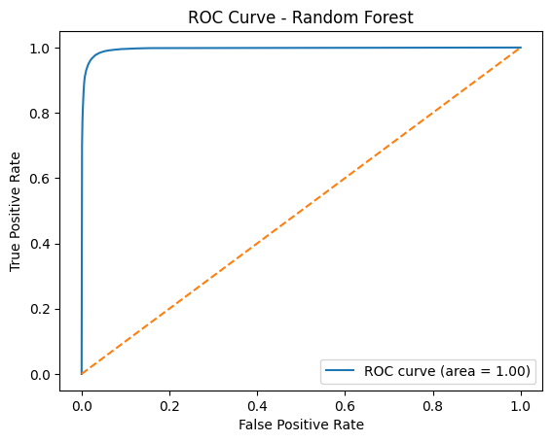
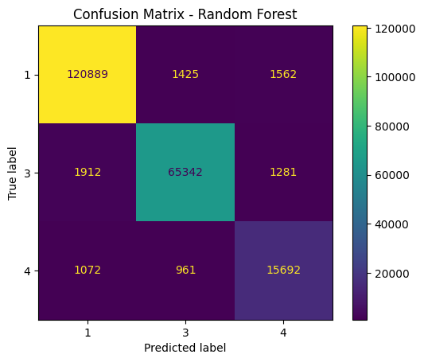
XGBoost
XGBoost is an advanced, optimized implementation of gradient boosting that builds a strong predictive model by combining many weak learners (decision trees) in sequence. Each new tree corrects the errors of the previous ones.
- Boosting technique: Trees are added sequentially, improving prediction step-by-step.
- Fast & Efficient: Uses parallel computation, tree pruning, and caching for speed.
Why Use XGBoost for DDoS Attack Detection ?
XGBoost is known for its exceptional predictive power. It often outperforms other algorithms like Random Forest, SVM, or Logistic Regression in terms of detection accuracy and precision. This is crucial in DDoS detection, where false negatives (missing an attack) can be very dangerous. DDoS traffic data often has nonlinear and complex interactions between features. XGBoost can capture intricate feature interactions due to its boosting nature — each new tree focuses on correcting the errors of the previous ones. DDoS datasets are often imbalanced (few attack instances compared to normal traffic). XGBoost has built-in options like scale_pos_weight to handle imbalance, helping reduce false positives and false negatives. Despite being powerful, XGBoost is highly optimized for speed with Parallelized tree construction and Hardware optimization (e.g., GPU support) This makes it suitable for near-real-time detection scenarios. XGBoost includes L1 and L2 regularization, which helps prevent overfitting — a common issue when training on noisy or limited DDoS attack data.

Classification Report:
Accuracy : 0.9585
Class | Precision | Recall | F1-Score | Support
1 | 0.98 | 0.97 | 0.97 | 123876
3 | 0.97 | 0.95 | 0.96 | 68535
4 | 0.81 | 0.91 | 0.86 | 17725
Macro Avg | 0.92 | 0.94 | 0.93 | 210136
Weighted Avg | 0.96 | 0.96 | 0.96 | 210136

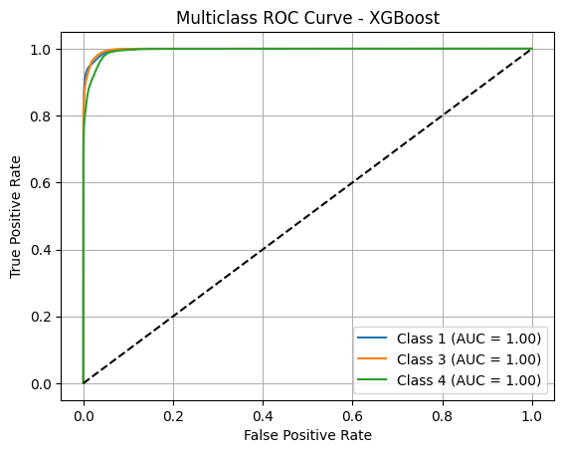
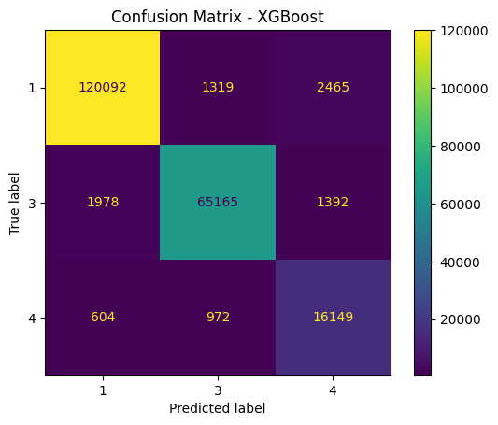

LightGBM
LightGBM (Light Gradient Boosting Machine) is a fast, high-performance gradient boosting framework developed by Microsoft. It builds decision trees leaf-wise (instead of level-wise like XGBoost), which makes it:
- More accurate, especially on large datasets.
- supports Parallel and GPU training
Why Use LightGBM for DDoS Attack Detection ?
LightGBM is extremely fast compared to XGBoost and Random Forest because it uses Histogram-based decision trees Leaf-wise tree growth with depth limitations This makes it perfect for real-time or large-scale DDoS detection systems DDoS detection often involves millions of packets/flows. LightGBM is optimized for high-dimensional and large-volume data, making it suitable for network traffic analysis and deep packet inspection. LightGBM supports L1/L2 regularization and early stopping, which helps prevent overfitting. It performs well on imbalanced datasets (common in DDoS scenarios) by allowing you to set custom loss functions or use class weights. Supports categorical features directly without needing one-hot encoding — a huge plus when working with protocol types, flags, or packet labels. Can easily handle sparse or missing data in traffic logs. Like XGBoost, LightGBM provides feature importance scores. Integrates well with SHAP values for interpretability — helpful for cybersecurity teams to understand what’s triggering an alert. While not natively online, LightGBM can be periodically retrained with new traffic data to adapt to evolving DDoS patterns.

Classification Report
Accuracy : 0.9582
Labels | Precision | Recall | F1-Score | Support
1 | 0.98 | 0.97 | 0.97 | 123876
3 | 0.96 | 0.96 | 0.96 | 68535
4 | 0.81 | 0.91 | 0.86 | 17725
Macro Avg | 0.92 | 0.94 | 0.93 | 210136
Weighted Avg | 0.96 | 0.96 | 0.96 | 210136

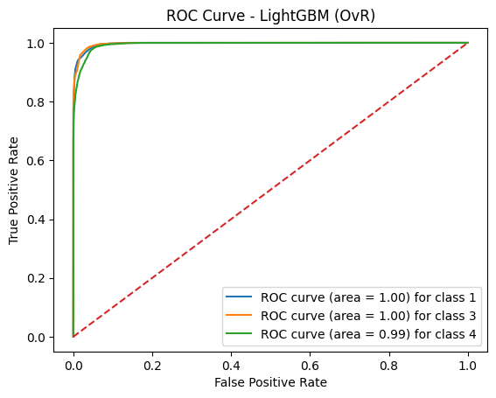
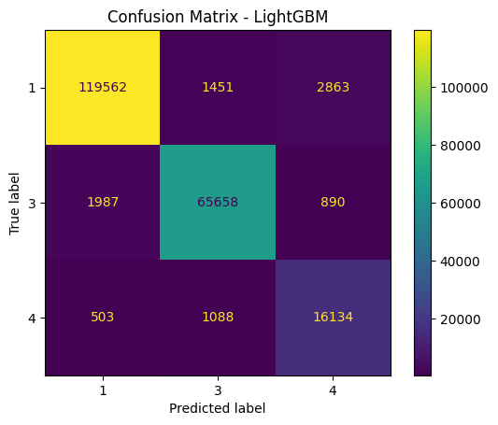
Naive Bayes
Naive Bayes is a simple yet powerful probabilistic classifier based on Bayes' Theorem, assuming independence between features. It works by:
- Calculating the probability of each class (e.g., normal vs. DDoS) given the input features.
- Choosing the class with the highest probability.
Why Use Naive Bayes for DDoS Attack Detection ?
Naive Bayes is a simple probabilistic classifier based on Bayes' theorem, assuming feature independence. It is known for its speed and efficiency on small datasets, but its assumptions often don't hold true for complex tasks like DDoS detection. While it can serve as a lightweight, baseline model, its performance generally lags behind more advanced models like Random Forest or XGBoost due to its oversimplified approach. In DDoS detection, where features such as packet inter-arrival time, flow size, and flag counts are interdependent, Naive Bayes often fails to capture the true patterns. However, it can still be useful in initial exploratory analyses or as a benchmark. Despite its limitations, its quick training time and low computational cost can be advantageous in resource-constrained environments or for real-time preliminary alerts.
Classification Report
Accuracy : 0.5326
Labels | Precision | Recall | F1-Score | Support
1 | 0.94 | 0.36 | 0.52 | 123876
3 | 0.44 | 0.84 | 0.58 | 68535
4 | 0.31 | 0.54 | 0.40 | 17725
Macro Avg | 0.56 | 0.58 | 0.50 | 210136
Weighted Avg | 0.72 | 0.53 | 0.53 | 210136
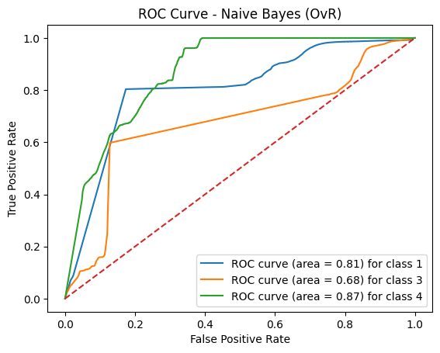

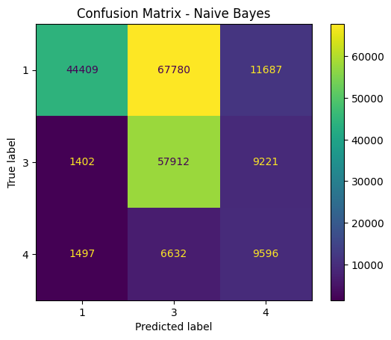
Multilayer Perceptron
An MLP is a type of deep learning neural network. It’s composed of multiple layers of neurons. Each neuron in a layer is connected to every neuron in the next layer — hence the term “fully connected”. MLP Works By :
- Each input feature (like packet length, duration, etc.) is multiplied by a weight and passed through an activation function.
- Over time, the MLP learns patterns in the input data that help it distinguish between normal and malicious traffic.
Why MLP for DDOS Detection
MLP is a type of feedforward neural network consisting of fully connected layers. It can model non-linear relationships between features, making it theoretically suitable for DDoS detection. However, vanilla MLPs often struggle with high-dimensional tabular data, especially when compared to ensemble models like Random Forest or advanced deep models like ResNet-style MLP. MLPs require careful hyperparameter tuning, and they are prone to overfitting if the dataset is imbalanced or noisy. In the context of DDoS detection, MLPs can learn traffic patterns but may not generalize well unless enhanced with techniques like dropout, batch normalization, or deeper architectures. While they can perform adequately with proper preprocessing and feature selection, MLPs are typically outperformed by tree-based models or more advanced deep learning structures in intrusion detection tasks.
Classification Report
Accuracy : 0.4004
Label | precision | recall | F1-Score | support
0 | 1.00 | 0.13 | 0.22 | 123876
1 | 0.35 | 1.00 | 0.52 | 68535
2 | 0.00 | 0.00 | 0.00 | 17725
Macro Avg | 0.45 | 0.38 | 0.25 | 210136
Weighted Avg | 0.70 | 0.40 | 0.30 | 210136

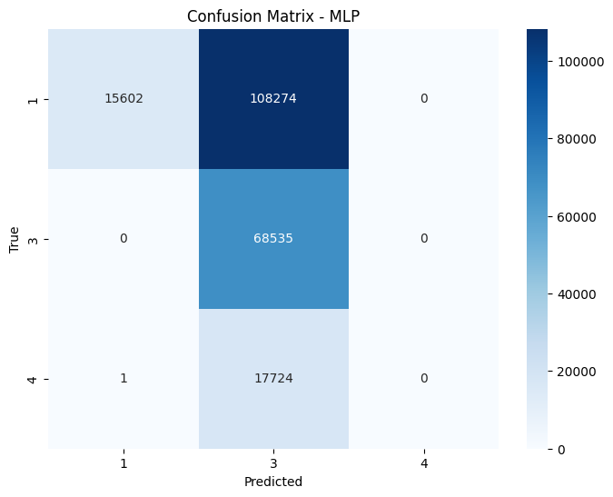
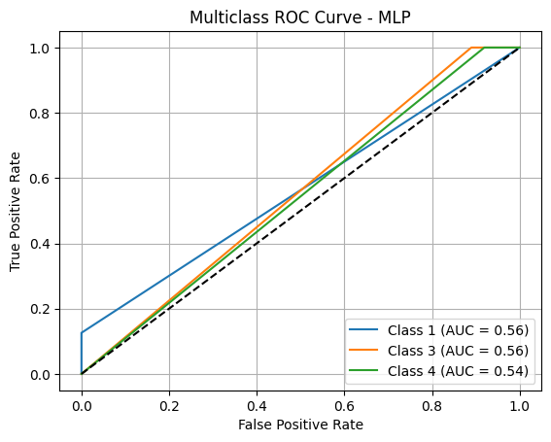
Block Diagram – MLP

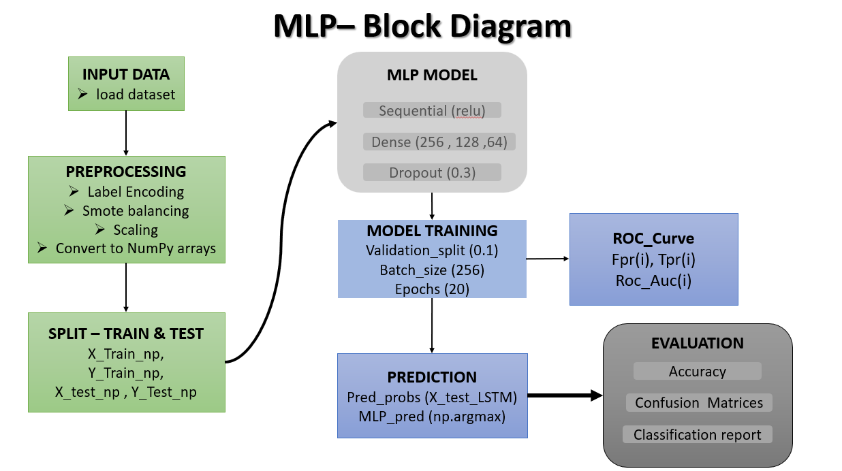
RESNET STYLE MLP
A ResNet-style MLP is a Multilayer Perceptron (MLP) that uses ideas from ResNet (Residual Networks) — originally designed for image classification — but adapted for tabular data like what we use in DDoS detection.
- They learn faster and usually generalize better on test data — especially with lots of features like in DDoS datasets.
- They allow the model to "bypass" unnecessary transformations.
Why Resnet in DDOS Detection
ResNet-style MLPs incorporate residual connections into deep fully connected neural networks, which help mitigate the vanishing gradient problem and enable deeper architectures. These connections allow the model to learn both simple and complex feature representations, making them more effective than traditional MLPs. In DDoS detection, ResNet-style MLPs can capture intricate relationships in network traffic data, especially when trained on well-processed, normalized features. Compared to basic MLPs or even some ensemble methods, they often achieve better accuracy due to improved gradient flow and deeper feature extraction. This makes them suitable for detecting subtle, evolving DDoS patterns in real time. Though they require more computational resources and careful tuning, their capacity to generalize well over complex datasets gives them an edge in high-stakes security applications.
CLASSIFICATION REPORT :
Accuracy : 0.8714
Label | precision | recall | F1-Score | support
0 | 0.9735 | 0.8607 | 0.9137 | 123876
1 | 0.9352 | 0.8644 | 0.8984 | 68535
2 | 0.4629 | 0.9731 | 0.6273 | 17725
Macro Avg | 0.7905 | 0.8994 | 0.8131 | 210136
Weighted Avg | 0.9179 | 0.8714 | 0.8845 | 210136
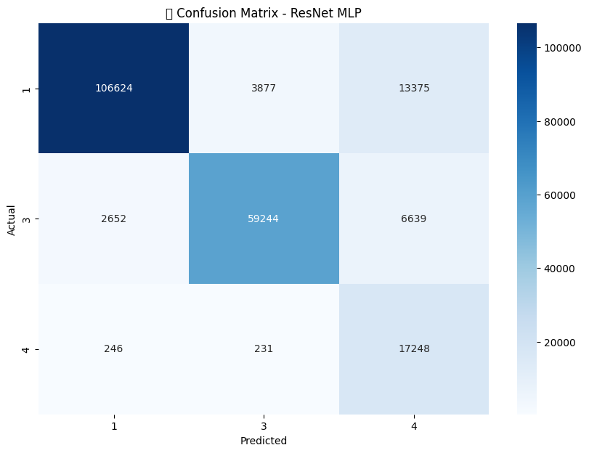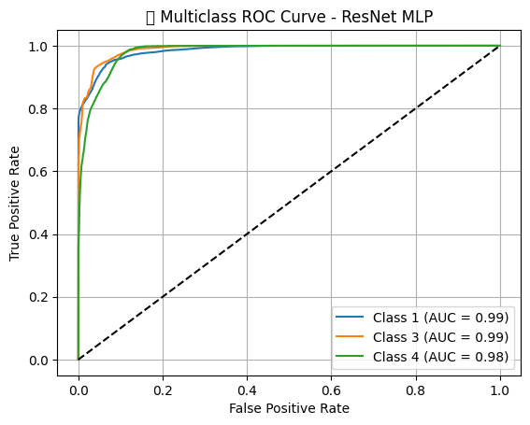

Block Diagram - Resnet

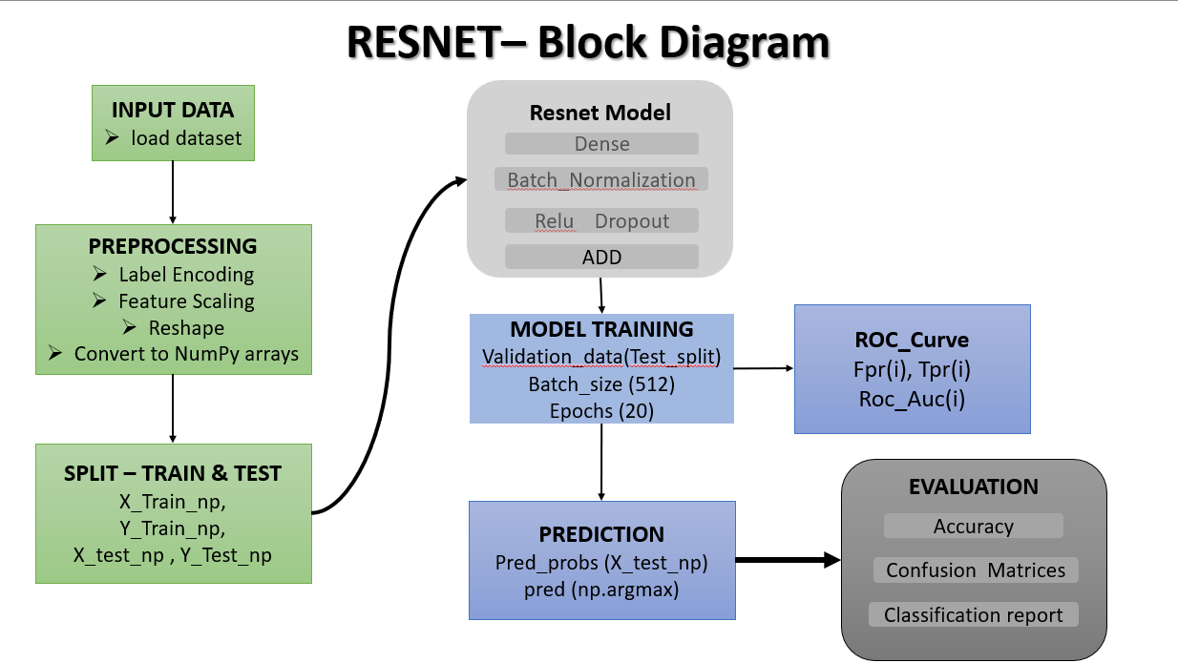
LONG SHORT TERM MEMORY
LSTM is a special type of Recurrent Neural Network that’s great at learning sequential and time-series data.
- It’s designed to remember information over time, which is super helpful when the pattern you want to detect unfolds over a series of events — like network traffic during a DDoS attack.
Why LSTM in DDOS Detection
LSTM is a type of recurrent neural network designed to capture sequential dependencies in time-series data. Its memory cells and gating mechanisms make it ideal for tasks involving temporal patterns. In DDoS detection, LSTMs excel in analyzing time-based traffic behaviors, such as sudden spikes or sustained attack flows. Unlike traditional models that view each packet or flow independently, LSTMs can consider the order and timing of events, making them powerful for detecting sophisticated, slow-burning, or periodic DDoS attacks. They outperform static models like Naive Bayes or Random Forest when temporal context is crucial. However, LSTMs require significant computational power and large datasets to train effectively, and they may be slower in real-time environments. Still, for systems where detecting patterns over time is critical, LSTM offers a substantial advantage.
Classification Report :
Accuracy : 0.9398
Label | precision | recall | F1-Score | support
1 | 0.98 | 0.96 | 0.97 | 123876
3 | 0.96 | 0.92 | 0.94 | 68535
4 | 0.68 | 0.89 | 0.77 | 17725
Macro Avg | 0.87 | 0.92 | 0.89 | 210136
Weighted Avg | 0.95 | 0.94 | 0.94 | 210136
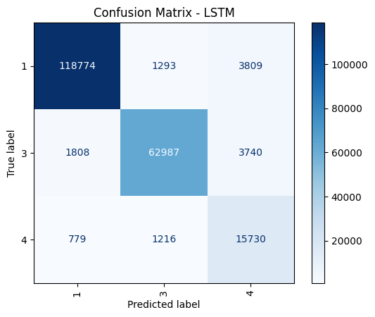

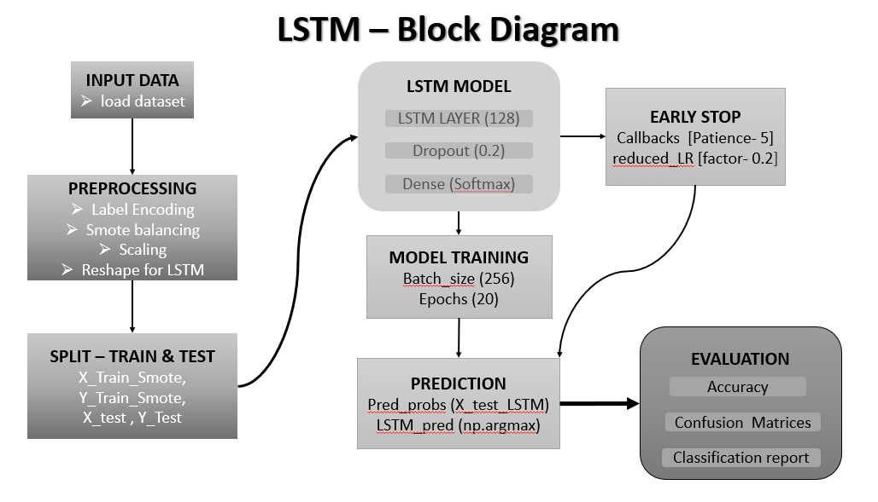
Models Comparison Summary :

 | Model | Accuracy | Precision  (Macro Avg) | Recall  (Macro Avg) | F1-Score  (Macro Avg)
1 | Random Forest | 0.9609 | 0.93 | 0.94 | 0.93
2 | XGBoost | 0.9585 | 0.92 | 0.94 | 0.93
3 | LightGBM | 0.9582 | 0.92 | 0.94 | 0.93
4 | Naive Bayes | 0.5326 | 0.56 | 0.58 | 0.50

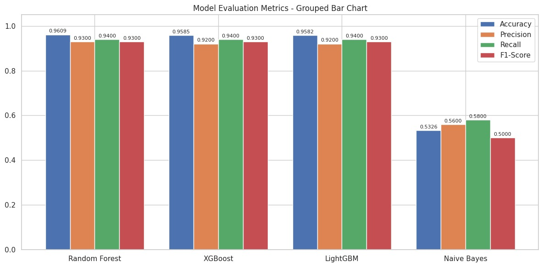
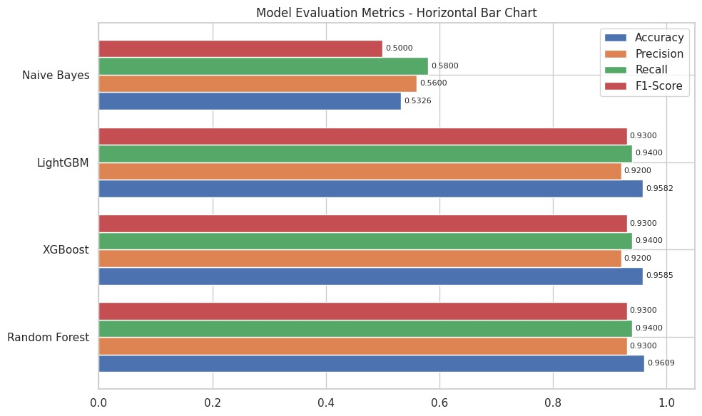

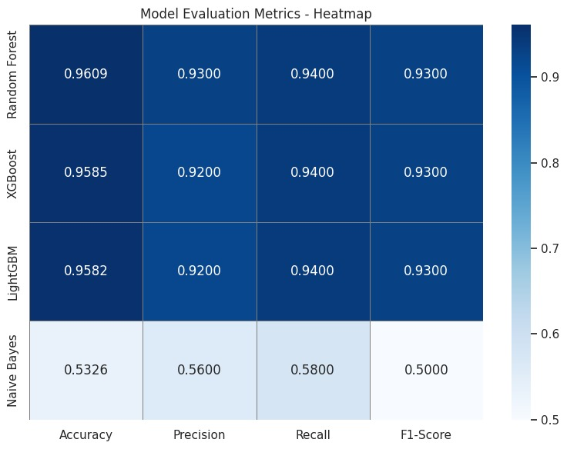
 | Model | Accuracy | Precision  (Macro Avg) | Recall  (Macro Avg) | F1-Score  (Macro Avg)
1 | Resnet Style MLP | 0.8714 | 0.7905 | 0.8994 | 0.8131
2 | MLP | 0.4004 | 0.45 | 0.38 | 0.25
3 | LSTM | 0.9398 | 0.87 | 0.92 | 0.89


